**Bootstrap Cards**

**Examples:**

<https://getbootstrap.com/docs/4.0/examples/pricing/>

# Pricing

Quickly build an effective pricing table for your potential customers with this Bootstrap example. It's built with default Bootstrap components and utilities with little customization.

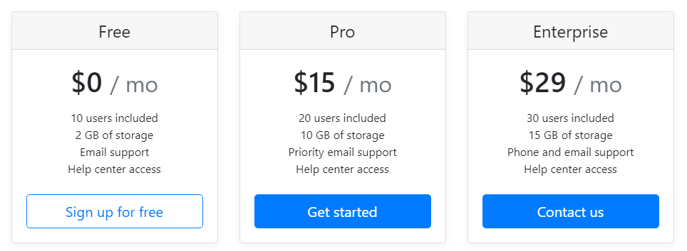

**Bootsnipp Examples:**

<https://bootsnipp.com/snippets/55ExM>

Cards

Bootstrap’s cards provide a flexible and extensible content container with multiple variants and options.

## **About**

A **card** is a flexible and extensible content container. It includes options for headers and footers, a wide variety of content, contextual background colors, and powerful display options. If you’re familiar with Bootstrap 3, cards replace our old panels, wells, and thumbnails. Similar functionality to those components is available as modifier classes for cards.

## **Example**

Cards are built with as little markup and styles as possible, but still manage to deliver a ton of control and customization. Built with flexbox, they offer easy alignment and mix well with other Bootstrap components. They have no margin by default, so use [spacing utilities](https://getbootstrap.com/docs/4.0/utilities/spacing/) as needed.

Below is an example of a basic card with mixed content and a fixed width. Cards have no fixed width to start, so they’ll naturally fill the full width of its parent element. This is easily customized with our various [sizing options](https://getbootstrap.com/docs/4.0/components/card/#sizing).

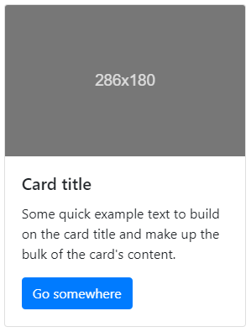

<div class="card" style="width: 18rem;">

<img class="card-img-top" src="..." alt="Card image cap">

<div class="card-body">

<h5 class="card-title">Card title</h5>

<p class="card-text">Some quick example text to build on the card title and make up the bulk of the card's content.</p>

<a href="#" class="btn btn-primary">Go somewhere</a>

</div>

</div>

**Basic Syntax:**

<div class="card">

<div class="card-header">

Card Header

</div>

<div class="card-body">

Card Body

</div>

<div class="card-footer">

Card Footer

</div>

</div>

**Code:**

**Index7.html:**

<!DOCTYPE html>

<html lang="en" dir="ltr">

<head>

<meta charset="utf-8">

<title>TinDog</title>

<!-- Google Fonts -->

<link rel="stylesheet" href="http://fonts.googleapis.com/css?family=Monserrat|Ubuntu">

<!-- Add Bootstrap Here-->

<!-- Stylesheet -->

<link rel="stylesheet" href="https://cdn.jsdelivr.net/npm/bootstrap@4.0.0/dist/css/bootstrap.min.css" integrity="sha384-Gn5384xqQ1aoWXA+058RXPxPg6fy4IWvTNh0E263XmFcJlSAwiGgFAW/dAiS6JXm" crossorigin="anonymous">

<link rel="stylesheet" href="css/styles6.css">

<!--Add style sheet-->

<!-- Font Awesome -->

<script defer src="http://use.fontawesome.com/releases/v5.0.7/js/all.js"></script>

<!--Add awsome fonts and icons like button icons-->

<!-- Link JavaScript of Bootstrap -->

<!-- Bootstrap Scripts -->

<script src="https://code.jquery.com/jquery-3.2.1.slim.min.js" integrity="sha384-KJ3o2DKtIkvYIK3UENzmM7KCkRr/rE9/Qpg6aAZGJwFDMVNA/GpGFF93hXpG5KkN" crossorigin="anonymous"></script>

<script src="https://cdn.jsdelivr.net/npm/popper.js@1.12.9/dist/umd/popper.min.js" integrity="sha384-ApNbgh9B+Y1QKtv3Rn7W3mgPxhU9K/ScQsAP7hUibX39j7fakFPskvXusvfa0b4Q" crossorigin="anonymous"></script>

<script src="https://cdn.jsdelivr.net/npm/bootstrap@4.0.0/dist/js/bootstrap.min.js" integrity="sha384-JZR6Spejh4U02d8jOt6vLEHfe/JQGiRRSQQxSfFWpi1MquVdAyjUar5+76PVCmYl" crossorigin="anonymous"></script>

</head>

<body>

<!-- section 1 -->

<section id="title">

<div class="container-fluid">

<!-- Nav Bar -->

<nav class="navbar navbar-expand-lg navbar-dark ">

<!-- Make transparent Header so remove bg-dark -->

<a class="navbar-brand" href="">tindog</a>

<button class="navbar-toggler" type="button" data-bs-toggle="collapse" data-bs-target="#navbarTogglerDemo02" aria-controls="navbarTogglerDemo02" aria-expanded="false" aria-label="Toggle navigation">

<span class="navbar-toggler-icon"></span>

</button>

<div class="collapse navbar-collapse" id="navbarTogglerDemo02">

<ul class="navbar-nav ml-auto">

<li class="nav-item">

<a class="nav-link" href="">Contact</a>

</li>

<li class="nav-item">

<a class="nav-link" href="">Pricing</a>

</li>

<li class="nav-item">

<a class="nav-link" href="">Download</a>

</li>

</ul>

</div>

</nav>

<!-- title -->

<div class="row">

<!--Now take a row and divide it into 2 columns of large 6 units -->

<div class="col-lg-6">

<!-- First column contains heading and buttons -->

<h1>Meet new and interesting dogs nearby.</h1>

<button type="button" class="btn btn-dark btn-lg download-button"><i class="fab fa-apple"></i> Download</button>

<button type="button" class="btn btn-outline-light btn-lg download-button"><i class="fab fa-google-play"></i> Download</button>

</div>

<div class="col-lg-6">

<!-- @nd column contains image -->

<img class="title-image" src="D:\University\Web Notes\Web Development Codes\CSS\TinDog Start Here\images\iphone6.png" alt="iphone-mockup"> <!-- Or simply link is images\iphone6.png -->

</div>

</div>

</div>

</section>

<!-- Next Sectioon starts here section 2 -->

<!-- Features -->

<section id="features">

<div class="row">

<div class="feature-box col-lg-4">

<i class="icon fas fa-check-circle fa-4x"></i> <!-- check circle icon 4x is size -->

<h3>Easy to use.</h3>

<p>So easy to use, even your dog could do it.</p>

</div>

<div class="feature-box col-lg-4">

<i class="icon fas fa-bullseye fa-4x"></i> <!-- bullseye icon -->

<h3>Elite Clientele</h3>

<p>We have all the dogs, the greatest dogs.</p>

</div>

<div class="feature-box col-lg-4">

<i class="icon fas fa-heart fa-4x"></i> <!-- heart icon -->

<h3>Guranteed to work.</h3>

<p>Find the love of your dog's life or your money back</p>

</div>

</div>

</section>

<!-- Next Sectioon starts here section 3 -->

<!-- Testimonials -->

<section id="testimonials">

<div id="testimonial-carousel" class="carousel slide" data-ride="false">

<div class="carousel-inner">

<div class="carousel-item active">

<h2>I no longer have to sniff other dogs for love. I've found the hottest Corgi on TinDog. Woof.</h2>

<img class="testimonial-image" src="images\dog-img.jpg" alt="dog profile">

<em>Pebbles, New York</em>

</div>

<div class="carousel-item">

<h2 class="testimonial-text">My dog used to be so lonely, but with TinDog's help, they've found the love of their life.

I think.</h2>

<img class="testimonial-image" src="images/lady-img.jpg" alt="lady-profile">

<em>Beverly, Illinois</em>

</div>

</div>

<a class="carousel-control-prev" href="#testimonial-carousel" role="button" data-slide="prev">

<span class="carousel-control-prev-icon"></span>

</a>

<a class="carousel-control-next" href="#testimonial-carousel" role="button" data-slide="next">

<span class="carousel-control-next-icon"></span>

</a>

</div>

</section>

<!-- Next Sectioon starts here section 4 -->

<!-- Press -->

<section id="press">

<img class="press-logo" src="images\TechCrunch.png" alt="tc-logo">

<img class="press-logo" src="images\tnw.png" alt="tnw-logo">

<img class="press-logo" src="images\bizinsider.png" alt="biz inseider-logo">

<img class="press-logo" src="images\mashable.png" alt="mashable-logo">

</section>

<!-- Next Sectioon starts here section 5 -->

<!-- Pricing -->

<section id="pricing">

<h2>A Plan for Every Dog's Needs</h2>

<p>Simple and affordable plan for you and your dog.</p>

<!--<div class="card-deck"> This class is used to place cards horizontally -->

<div class="row">

<div class="pricing-column col-lg-4 ">

<div class="card "> <!-- col-md-6 when this site is opened in mobile or tab it will change site cards layout -->

<div class="card-header">

<h3>Chihuahua</h3>

</div>

<div class="card-body">

<h2>Free</h2>

<p>5 Matches Per Day</p>

<p>10 Messages Per DAy</p>

<p>Unlimited App Usage</p>

<button class=" btn-lg btn-block btn-outline-dark" type="button">Sign Up</button>

</div>

</div>

</div>

<div class="pricing-column col-lg-4 ">

<div class="card">

<div class="card-header">

<h3>Labrador</h3>

</div>

<div class="card-body">

<h2>$49 / mo</h2>

<p>Unlimited Matches</p>

<p>Unlimited Messages</p>

<p>Unlimited App Usage</p>

<button class=" btn-lg btn-block btn-dark" type="button">Sign Up</button>

</div>

</div>

</div>

<div class="pricing-column col-lg-4 ">

<div class="card">

<div class="card-header">

<h3>Mastiff</h3>

</div>

<div class="card-body">

<h2>$99 / mo</h2>

<p>Pirority Listing</p>

<p>Unlimited Matches</p>

<p>Unlimited Messages</p>

<p>Unlimited App Usage</p>

<button class=" btn-lg btn-block btn-dark" type="button">Sign Up</button>

</div>

</div>

</div>

<!--</div> -->

</div>

</section>

<!-- Next Sectioon starts here section 6 -->

<!-- Call To Action -->

<section id="cta">

<h3>Find the True Love of Your Dog's Life Today.</h3>

<button type="button">Download</button>

<button type="button">Download</button>

</section>

<!-- Next Sectioon starts here section 7 -->

<!-- Footer -->

<section id="footer">

<p>© Copyright TinDog</p>

</section>

</body>

</html>

**Styles6.css:**

/************************ TAG SSELECTORS **********************/

/* These are global tags because they change the whole body */

h1{

font-family: "Montserrat-Black";

font-size: 3.5rem;

line-height: 1.5;

font-weight: bold;

}

h2{

font-family: "Montserrat-Bold";

font-size: 3rem;

line-height: 1.5;

font-weight: bold;

}

h3{

font-family: "Montserrat-Bold";

}

p{

color: #8f8f8f;

}

body{

font-family: "Monserrat";

}

/************************ CLASS SSELECTORS **********************/

.container-fluid{

padding: 3% 15%;

}

/* Navigatioon Bar */

.navbar{

padding: 0 0 4.5rem; /* 0 on top 0 on left and right and 4.5rem on bottom */

}

.navbar-brand{

font-family: "Ubuntu"; /* tindog t style changes */

font-size: 2.5rem;

font-weight: bold;

}

.nav-item{

padding: 0 18px;

}

.nav-link{

font-size: 1.2rem;

font-family: "Montserrat-Light";

}

/* Download Buttons */

.download-button{

margin: 5% 3% 5% 0; /* top=5%, right=3%, bottom=5%, left=0 */

}

/* Title Image */

.title-image{

width: 60%;

transform: rotate(25deg); /* Rotate image to style */

}

.feature-box{

text-align: center;

padding: 4.5%;

}

.icon{

color: #ef8172;

margin-bottom: 1rem;

}

.icon:hover{

color: #ff4c68;

}

/* Testimonial Section */

.testimonial-image{

width: 10%;

border-radius: 100%;

margin: 20px;

}

/* Press Section */

.press-logo{

width: 15%;

margin: 20px 20px 50px;

}

/* Carousel Section */

.carousel-item{

padding: 7% 50px;

height: 500px;

}

/* Pricing Section */

.pricing-column{

padding: 3% 2%;

}

/************************ ID SSELECTORS ************************/

#title{

background-color: #ff4c68;

color:#fff; /* white = #fff */

}

/* Features Section */

#features{

padding: 7% 15%;

}

/* Testimonial Section */

#testimonials{

padding: 7% 15%;

text-align: center;

background-color: #ef8172;

color: #fff;

}

/* Press Section */

#press{

background-color: #ef8172;

text-align: center;

padding-bottom: 3%;

}

/* Pricing Section */

#pricing{

padding: 100px;

text-align: center;

}